Name: MHT No: Date:
Address:

However you’ve chosen to donate, please bring this form with you to hand in at reception. Thank You!
BANK DETAILS
The Mary How Trust For Cancer Prevention
Sort Code: 20 - 42 - 58
One-Off Donations account: 33526119
Standing Order account: 53517691
ONE- OFF DONATION
Amount: £350 £400 Other Amount £_____
Via: Card Cash Cheque Website (Paypal) Bank Transfer
Date donation made: _____/_____/_____

REGULAR MONTHLY DONATION (Standing Order)
I will set up myself OR Please instruct my bank to set up using the details below:
Monthly Amount: £10 £15 £30 £_______
Day of the month payments should be taken on: _________ & Payments to start from: ________________
Signed: _______________________________________ Date: _____/_____/_____
Your Bank Account Number: _____________________________ Your Sort Code: _______________
Payment reference for your bank:
Name Of Your Bank: _____________________________ Your Bank’s Postcode: __________________
Your Bank’s Full Address: _________________________________________________________________
BANK USE – MARY HOW TRUST BANK DETAILS:
Barclays Bank plc Sort Code: 20-42-58 Account No. 53517691
Please note the onus is on you to contact your bank if you wish to stop your payments.
AND / OR…

GIFT AID DECLARATION
Please select one of the following options:
I am a UK taxpayer Yes
No
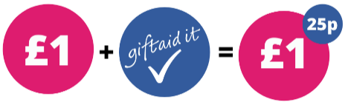

If you are a UK taxpayer you can boost your donation by 25p for every £1 you donate, making your gift go even further!

